***The Acid Fast Club***

**Winter Meeting 2016 & AGM**

to be held on

Friday 8th January 2016 at



Local Organisers:

**Helen Fletcher & Jackie Cliff**

[Helen.Fletcher@lshtm.ac.uk](mailto:Helen.Fletcher@lshtm.ac.uk)

[Jackie.Cliff@lshtm.ac.uk](mailto:Jackie.Cliff@lshtm.ac.uk)

 8th January 2016 Programme



**13:00 - 15:10 Session 1**

**15:10 - 16:00 Refreshments and AFC AGM**

**16:00 - 18:20 Session 2**

**18:20 - 19:30 Drinks reception and buffet**

**Nominations -** The following nominations for membership have been received:

**Mahdad Noursadeghi,** UCL; Nominated by Paul Elkington, seconded by Adrian Martineau

**Rachel Lai**, The Crick; Nominated by Gerald Larroy-Maumus, seconded by Teresa Cortes

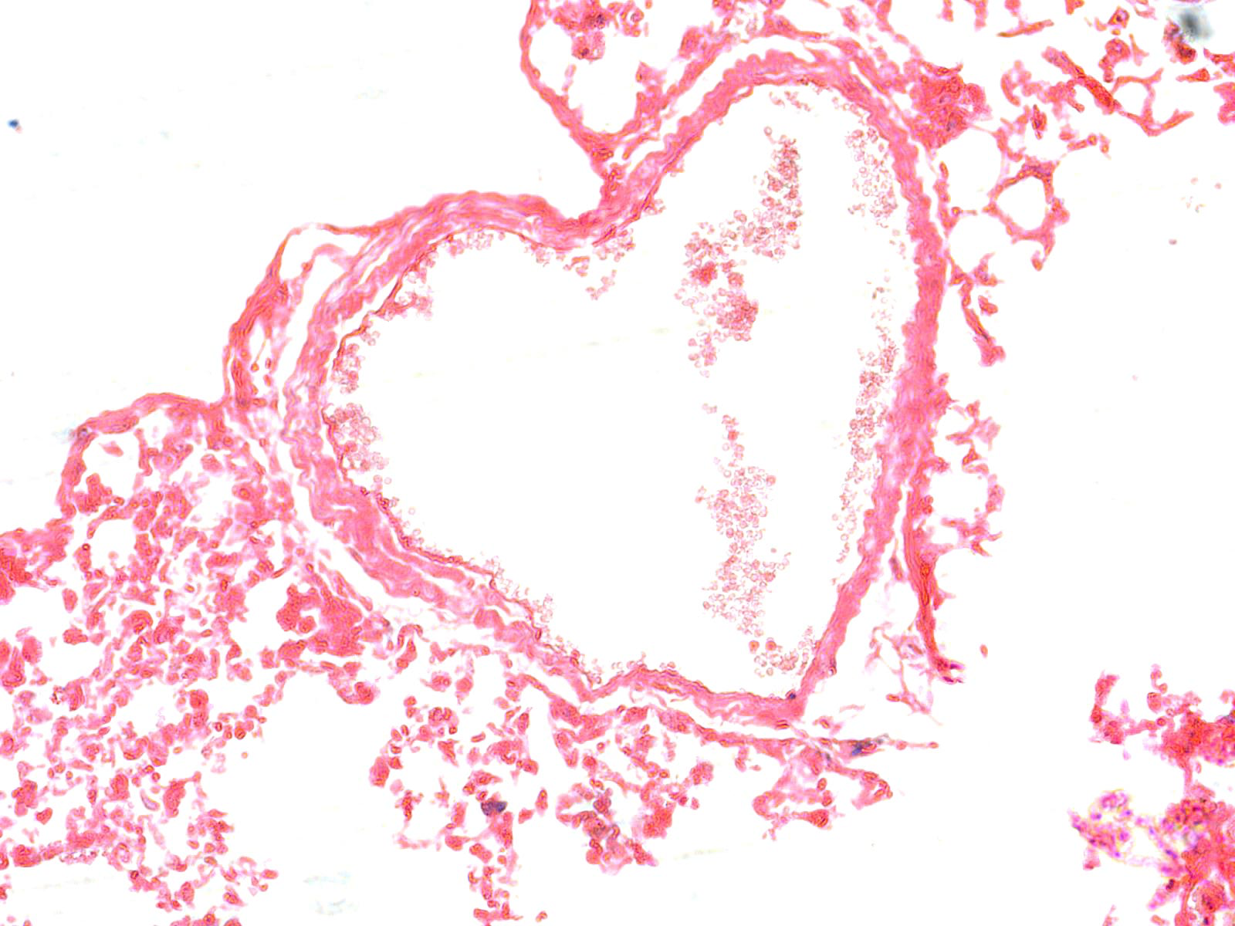*TB infected mouse lung tissue section, courtesy of research student Maria Podinovskaia, LSHTM*

8th January 2016 Programme

**Domestic arrangements**

The meeting will be held in The John Snow Lecture Theatre

Tea and coffeewill be served at 15:10 in The South Courtyard Cafe

Wine and soft drinks will be served with a finger buffet at 18:20 **for £20, also in** The South Courtyard Cafe

**Booking**

Please **register and pay** using Eventbrite,

[https://acid-club-winter-meeting.eventbrite.co.uk](https://acid-club-winter-meeting.eventbrite.co.uk/)

***and*** email booking form to Helen Fletcher, [**Helen.Fletcher@lshtm.ac.uk**](mailto:Helen.Fletcher@lshtm.ac.uk) or Jackie Cliff, [**Jackie.Cliff@lshtm.ac.uk**](mailto:Jackie.Cliff@lshtm.ac.uk) no later than December 22nd.

This will allow us to confirm numbers with the caterers before Christmas.

**Directions to the Venue**

All modes of travel are covered in detail by information at the following site:

http://www.lshtm.ac.uk/aboutus/contact/location.html

8th January 2016 Programme

**Offered papers**

Speakers are underlined & their affiliation indicated.

Speakers are reminded that the Constitution of the Club limits the length of each talk to 15 min.

**13:00 –15:10 Session 1 Welcome, Host presentations and Offered papers**

13:00 – 13:10 Welcome by Helen McShane

13:10 – 13:30 **The TB Centre at the London School of Hygiene & Tropical Medicine – who we are and what we do.** Helen Fletcher and Katherine Fielding; London School of Hygiene and Tropical Medicine

13:30 – 13:50 **Polyfunctional CD4 T-cells and *in vitro* mycobacterial growth inhibition detected in *Mycobacterium bovis* BCG-vaccinated UK infants**. Steven Smith, Andrea Zelmer, Rose Blitz, Helen Fletcher, Hazel Dockrell, London School of Hygiene and Tropical Medicine

13:50 – 14:10 ***Ex vivo* mycobacterialgrowth inhibition assays (MGIA) as a new tool for assessment of TB vaccines**. Andrea Zelmer, Satria Prabowo, Rachel Tanner, Elena Stylianou, Helen McShane, Helen Fletcher; London School of Hygiene and Tropical Medicine

14:10 – 14:30 **The C-terminal domain of protein kinase G is required for regulation of**

**glutamate catabolism in *Mycobacterium smegmatis*.** Nabanita Bhattacahatyya, M. Zimmerman, H. M. O’Hare; University of Leicester

14:30 – 14:50 **Parenteral Adenoviral Boost Enhances BCG Induced Protection, but not Long Term Survival in a Murine Model of Bovine TB**. Phil Hogarth, Daryan A. Kaveh, M. Carmen Garcia-Pelayo, Paul R. Webb, Esen E. Wooff, Véronique S. Bachy; Animal and Plant Health Agency

14:50 – 15:10 **A spatial model of *M. tuberculosis* in the lung**. Ruth Bowness**,** Stephen

Gillespie, Mark Chaplain; University of St. Andrews

**15:10 - 16:00 Refreshments and AGM**

**16:00 - 18:20 Session 2: Offered papers**

16:00 – 16:20 **The Suburban Cure–thoughts on dose and genetic susceptibility to TB.** Andrea Cooper and John E. Pearl; University of Leicester

16:20 – 16:40 **Does using aerosol and systemic routes of immunisation avoid anti-vector immunity and boost TB vaccine responses?** Zita-Rose Manjaly Thomas, Iman Satti, Stephanie Harris, Joel Meyer, Morven Wilkie, Michael Riste, Ali Hamidi, Sharon Sheehan, Alice Minhinnick, Henry Bettinson, Helen McShane, University of Oxford

16:40 – 17:00 **Investigating host regulatory pathways that limit immunopathology in tuberculosis**. Patience T. Brace, LB Tezera, JS Friedland, TM Millar, CG Proud, PT Elkington; University of Southampton

17:00 – 17:20 **Towards definition of an immunological basis of protection obtained by**

**prime-boost immunisation against bovine tuberculosis**. Hannah Metcalfe, Bernardo Villarreal-Ramos, Gareth J. Jones, Sabine Steinbach, W. Ivan

Morrison , Tom Connelley, Martin Vordermeier; Animal and Plant Health Agency

17:20 – 17:40 **Targeting the mycobacterial membrane using novel antimicrobial peptides for tuberculosis therapy**. Jasmeet Singh Khara, SM Newton, N Krishnan, I Uhra, M Priestman, PR Langford, PLR Ee, BD Robertson; Imperial College

17:40 – 18:00 **Circulating serum microRNAs as novel biomarkers for bovine tuberculosis.** Carolina N.Correia, Nicolas C. Nalpas, Kirsten E. McLoughlin, David A. Magee, Ronan G. Shaughnessy, John A. Browne, Adam O. Whelan, H. Martin Vordermeier, Eamonn Gormley, Bernardo Villarreal-Ramos, Stephen V. Gordon, David E. MacHugh; University College Dublin

18:00 – 18:20 **Objectively-measured coughing patterns in pulmonary tuberculosis**

Richard Turner, Graham Bothamley; Surinder Birring; Homerton University Hospital NHS Foundation Trust

**Booking form - The absolute deadline for booking is 22nd December 2015**

All attendees MUST fill out the booking form regardless of whether they require refreshments. Booking forms from non-members will not be accepted without the name of a sponsoring member (who does not need to attend).

Please complete the booking form and email it to Helen Fletcher, [**Helen.Fletcher@lshtm.ac.uk**](mailto:Helen.Fletcher@lshtm.ac.uk) or Jackie Cliff, [**Jackie.Cliff@lshtm.ac.uk**](mailto:Jackie.Cliff@lshtm.ac.uk). Please pay for your booking by Eventbrite at [https://acid-club-winter-meeting.eventbrite.co.uk](https://acid-club-winter-meeting.eventbrite.co.uk/)

|  |  |  |  |  |  |
| --- | --- | --- | --- | --- | --- |
| **Name** | **Affiliation / Sponsor** | **Member**  **Y/N**  **-/£5** | **Coffee/tea**  **Y/N** | **Wine reception and nibbles**  **Y/N** | **Total (£)** |
| Free | **20£** |
|  |  |  |  |  |  |
|  |  |  |  |  |  |
|  |  |  |  |  |  |
|  |  |  |  |  |  |
|  |  |  |  |  |  |
|  |  |  |  |  |  |
|  |  |  |  |  |  |
|  |  |  |  |  |  |
|  |  |  |  |  |  |

**Receipt of Payment for Winter Meeting Acid Fast Club 2016 – LSHTM.**

Name :………………………………………………………… Amount paid:…………………………………

Cheque received by local organiser (signature): ……………………………………………….

*Receipts will not be sent but can be collected at the meeting*