The Acid Fast Club

Winter Meeting 2015
& AGM

to be held on

Friday 9th January 2015

at
The National Institute for Medical Research
Mill Hill
London NW7 1AA

Local Organisers:
Teresa Cortes & Douglas Young
tcortes@nimr.mrc.ac.uk and dyoung@nimr.mrc.ac.uk

9th January 2015 Programme

13:00 - 15:10 Session 1
15:10 - 16:00 Refreshments and AFC AGM
16:00 - 18:10 Session 2
18:10 - 19:30 Drinks reception and buffet in the NIMR canteen

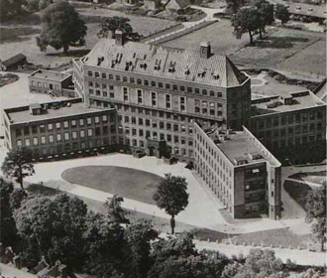
Nominations - The following nominations for membership have been received:

Nicholas Keep, Birkbeck College; Nominated by Sanjib Bhakta, seconded by Tine Arnvig

Gerald Larrouy-Maumus, Imperial; Nominated by Tine Arnvig, seconded by Teresa Cortes

David MacHugh, University College Dublin; Nominated by Steve Gordon, seconded by Graham Stewart

Domestic arrangements

The meeting will be in The Fletcher Hall, NIMR.
Tea and coffee will be served at 15:10 in the canteen

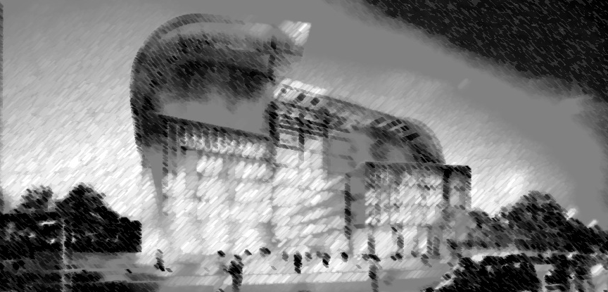
Wine and soft drinks will be served with a finger buffet at 18:10 in the canteen for £15
Booking
Please Please pay for your booking by Paypal at http://acidfastclub.uk/afc-winter-2015-meeting-registration/ if you can, and email the confirmation with the booking form to Teresa Cortes, tcortes@nimr.mrc.ac.uk no later than December 12th. If you do not use PayPal please send a cheque payable to the Acid Fast Club along with your booking form to Teresa Cortes

This will allow us to confirm numbers with the caterers before Christmas.
Offered papers
Speakers are underlined & their affiliation indicated.
Speakers are reminded that the Constitution of the Club limits the length of each talk to 15 min.

13:00 –15:10 Session 1 (Glyn Hewinson): History of AFC and Offered papers

13:00 – 13:30 A brief history of the Acid Fast Club. Ann Rawkins, Public Health England, Porton Down

13:30 – 13:50 Toll-like Receptor and Inflammasome Mediated Response in HIV-Tuberculosis-Associated Immune Reconstitution Inflammatory Syndrome. Rachel PJ Lai, Graeme Meintjes, Katalin A Wilkinson, Christine M Graham, Suzaan Marais, Helen Van der Plas, Armin Deffur, Charlotte Schutz, Chloe Bloom, Indira Munagala, Esperanza Anguiano, Rene Goliath, Gary Maartens, Jacques Banchereau, Damien Chaussabel, Anne O’Garra & Robert J Wilkinson; Division of Mycobacterial Research, MRC National Institute for Medical Research

13:50 – 14:10 Role of Rab20 during Mycobacterium tuberculosis phagosome trafficking. Laura Schnettger, Gang Pei & Maximiliano G. Gutierrez
Mycobacterial Research, MRC National Institute for Medical Research

14:10 – 14:30 M. tuberculosis dysregulates vitamin D metabolism.
Karolina D Witt, Zhican Wang, Kashaf Junaid, Anna K Coussens, David A Jolliffe, Robert J Wilkinson, Kenneth E Thummel & Adrian R Martineau; Queen Mary University of London.

14:30 – 14:50 Investigating the role of hepcidin and iron metabolism in a murine model of Mycobacterium tuberculosis infection. Rachel Harrington-Kandt, Elena Stylianou, Hal Drakesmith & Helen McShane; Jenner Institute, University of Oxford
14:50 – 15:10 The role of nitric oxide in the production of Rpf-dependent Mycobacteria. Sarah Glenn, Obolbek Turapov, Vadim Marakov, Bavesh Kana, Peter Andrew & Galina Mukamolova; Department of Infection, Immunity and Inflammation, University of Leicester

15:10 - 16:00 Refreshments and business meeting

16:00 - 18:10 Session 2 (Helen McShane): Offered papers and Douglas Young

16:00 – 16:20 Primary human airway epithelial cells are early responders to tuberculosis infection. Ann-Katrin Reuschl, M Edwards, D Connell, N Siddiqui, H Lambie, S Bremang, OM Kon, R Shattock & A Lalvani; Tuberculosis Research Centre, NHLI, Imperial College London
16:20 – 16:40 Helminth induced CD4⁺FoxP3⁺ T cells are associated with an impaired immune response to Mycobacterium tuberculosis. Frederic Toulza, Lilian Tsang, Michael Brown & Hazel Dockrell; London School of Hygiene and Tropical Medicine
16:40 – 17:00 Phenotypic resistance in mycobacteria is associated with the presence of lipid bodies not age of cells. Robert Hammond, Han Xiao, Katarina Orvacova & Stephen Gillespie; School of Medicine, University of St.Andrews

17:00 – 17:20 Pathogenic mycobateria achieve cellular persistence by inhibiting the Niemann-Pick type C disease cellular pathway. Paul Fineran, E. Lloyd-Evans, N. A. Lack, N. Platt, L. C. Davis, A. J. Morgan, R. Tatoturi, D. Kelly, S. Clark, A. Williams, I. Williams, W. Tynan, N. Al Eisa, A. Galione, D. Ory, D. Russell, M. Brenner, E. Sim & F. M. Platt; Department of Pharmacology, University of Oxford

17:20 – 17:40 Molecular profiling of the tuberculin skin test reveals diverse effects of HIV-1 infection in active tuberculosis. Lucy CK Bell, Gabriele Pollara, Mellissa Pascoe, Gillian Tomlinson, Rannakoe J. Lehloenya, Richard Meldau, Paul Elkington, Robert Miller, Alan Ramsey, Benjamin Chain, Keertan Dheda & Mahdad Noursadeghi

17:40 – 18:10 Mill Hill and the Acid Fast Club. Douglas Young; NIMR/Crick

Directions to the Venue

All modes of travel are covered in detail by information at the following site:
http://www.nimr.mrc.ac.uk/location-and-maps/

If you would like to park on site please email Teresa with your car make and registration number so security can be notified.

Also please notice that we need to inform security in advance of who is coming so registration is essential.
Booking form - The absolute deadline for booking is 12th December 2014
All attendees MUST fill out the booking form regardless of whether they require refreshments. Booking forms from non-members will not be accepted without the name of a sponsoring member (who does not need to attend).
Please complete the booking form and send it to Teresa Cortes, NIMR, The Ridgeway, NW7 1AA. Please pay for your booking by Paypal at http://www.acidfastclub.co.uk/ if you can, otherwise please send the booking form and a cheque payable to the Acid Fast Club. To use Paypal, select options for drinks and nibbles; this will be added to your PayPal cart, where you will be able to adjust the number required. The "continue shopping" option will allow you to return to the original page to select further items if required. When finished, select "View Cart" and you will be taken to PayPal to make final adjustments and payment.

Name | Affiliation / Sponsor | Member  Y/N  -/£5 | Coffee/tea  Y/N | Wine reception and nibbles  Y/N | Total (£)
Name | Affiliation / Sponsor | Member  Y/N  -/£5 | Free | 15£ | Total (£)

Receipt of Payment for Winter Meeting Acid Fast Club 2014 – NIMR.

Name :………………………………………………………… Amount paid:…………………………………

Cheque received by local organiser (signature): ……………………………………………….
Receipts will not be sent but can be collected at the meeting

